

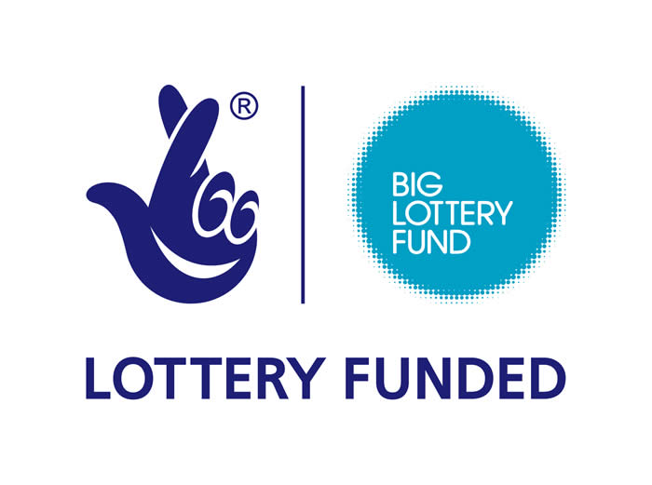



Toothill Big Local in conjunction

with Link & Learn Preschool

Invite you to join us for a

Christmas Fayre

Saturday 10th December

11am – 4pm

At The Toothill Farmhouse

Bodiam Drive, Toothill, Swindon, SN5 8BE

Free Entry